[](https://www.google.it/url?sa=i&rct=j&q=&esrc=s&source=images&cd=&cad=rja&uact=8&ved=0CAcQjRw&url=https://it.fotolia.com/id/25683909&ei=-llsVeTwAsPEmwXl54KIBg&bvm=bv.94455598,d.dGY&psig=AFQjCNGyEKRn5hXtl7MNhgTWzhHYx1gE-Q&ust=1433250581284336)[](http://www.google.it/imgres?imgurl=http://thumbs.dreamstime.com/t/i-bambini-cantano-42995832.jpg&imgrefurl=http://it.dreamstime.com/fotografia-stock-l-accumulazione-di-carit%C3%A0-divertente-va-maschera-di-parata-di-regno-che-corre-gli-spaventapasseri-dello-spaventapasseri-catturati-image42995845&h=160&w=293&tbnid=WKKA09RkoIStkM:&zoom=1&docid=UENOj6OxSyL3XM&ei=tX5tVaDVG-XCmAWu64Eo&tbm=isch&ved=0CD8QMyg7MDs49AM)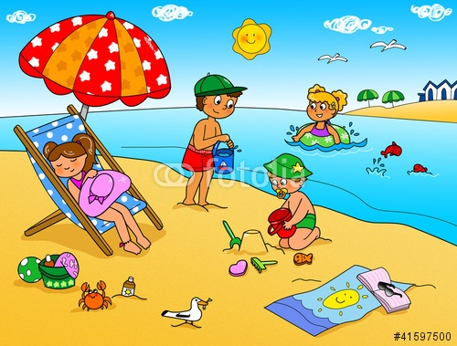

*Le Suore Francescane*